Extract movie reviews for any movie from IMDB and perform sentimental analysis

## Here we are extracting the agent sai srinivas athreya movie and performing sentimental anaylsis

library(rvest)

library(XML)

library(magrittr)

##agent sai srinivas athreya movie reviews extraction ##

a <- 10

agent <- NULL

rev <- NULL

url <- "https://www.imdb.com/title/tt10214826/reviews?ref_=tt_ov_rt"

murl <- read_html(as.character(paste(url,1, sep = "")))

rev <- murl %>% html_nodes(".show-more__control") %>% html_text()

agent <- c(agent,rev)

write(agent, "agent.csv")

getwd()

install.packages("syuzhet")

library("syuzhet")

library(lubridate)

library(ggplot2)

library(scales)

library(dbplyr)

library(reshape2)

txt = readLines(file.choose())

x <- iconv(txt, "UTF-8")

s <- get_nrc_sentiment(x)

head(s)

x[4]

get_nrc_sentiment('excellent')

## anger anticipation disgust fear joy sadness surprise trust negative positive

## 0 0 0 0 1 0 0 1 0 1

# Bar plot for emotion mining

barplot(colSums(s), las = 2, col = rainbow(10), ylab = 'Count', main = 'Emotion scores')

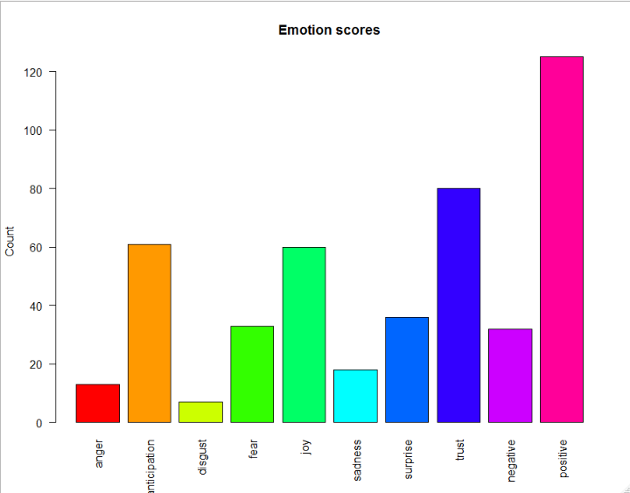

##In this sentimental analysis most of people positive word of mouth then any other sentiment